**Assignment 05: Assignment and practice of AI Image Generator**

## Task 1: Comparative Research – AI Image Generators

**Task:** Compare two AI image generators — **DALL·E (by OpenAI)** and **Midjourney  
Example Prompt Used:** *"A steampunk city under moonlight with flying airships and glowing lanterns."*

### **1. Image Quality**

* **DALL·E:** Produces clean, coherent images with a balanced composition. The resolution is good, but fine details may sometimes appear soft or slightly unrealistic in complex prompts.
* **Midjourney:** Known for stunning visual quality and artistic flair. Outputs are high-resolution, rich in texture, and often resemble professional digital art.

**Winner:** *Midjourney* — excels in producing visually striking, polished images.

**2. Prompt Accuracy**

* **DALL·E:** Interprets prompts with high accuracy, especially for real-world objects and clear descriptions. Handles literal prompts well.
* **Midjourney:** Creative and expressive, but may interpret prompts more abstractly. Sometimes adds stylistic elements not explicitly requested.

**Winner:** *DALL·E* — better for literal and factual prompt interpretation.

**3. Style Flexibility**

**DALL·E:** Versatile across different styles (realistic, cartoon, minimal), though results may lean toward a more "neutral" style unless clearly specified.

**Midjourney:** Extremely flexible and stylized. Easily generates artwork in surreal, fantasy, steampunk, cyberpunk, and painterly styles with rich aesthetics.

**Winner:** *Midjourney* — offers a wide range of artistic styles and creative output.

### **4. Usability**

* **DALL·E:** User-friendly interface (available via ChatGPT or Bing). Simple to use with drag-and-drop or text prompt. No installation needed.
* **Midjourney:** Runs via Discord, which may be confusing for beginners. Requires understanding of Discord commands and queues.

**Winner:** *DALL·E* — easier to access and use, especially for beginners.

### **5. Licensing & Terms**

* **DALL·E:** Allows users to use, modify, and commercially exploit images. OpenAI owns the model, but grants full rights to users for their creations.
* **Midjourney:** Paid users get commercial rights. Free users must credit Midjourney and cannot use images commercially. Images are often public by default.

**Winner:** *DALL·E* — more open and flexible licensing for all users.

### **Conclusion**

| **Feature** | **Winner** |
| --- | --- |
| Image Quality | Midjourney |
| Prompt Accuracy | DALL·E |
| Style Flexibility | Midjourney |
| Usability | DALL·E |
| Licensing & Terms | DALL·E |

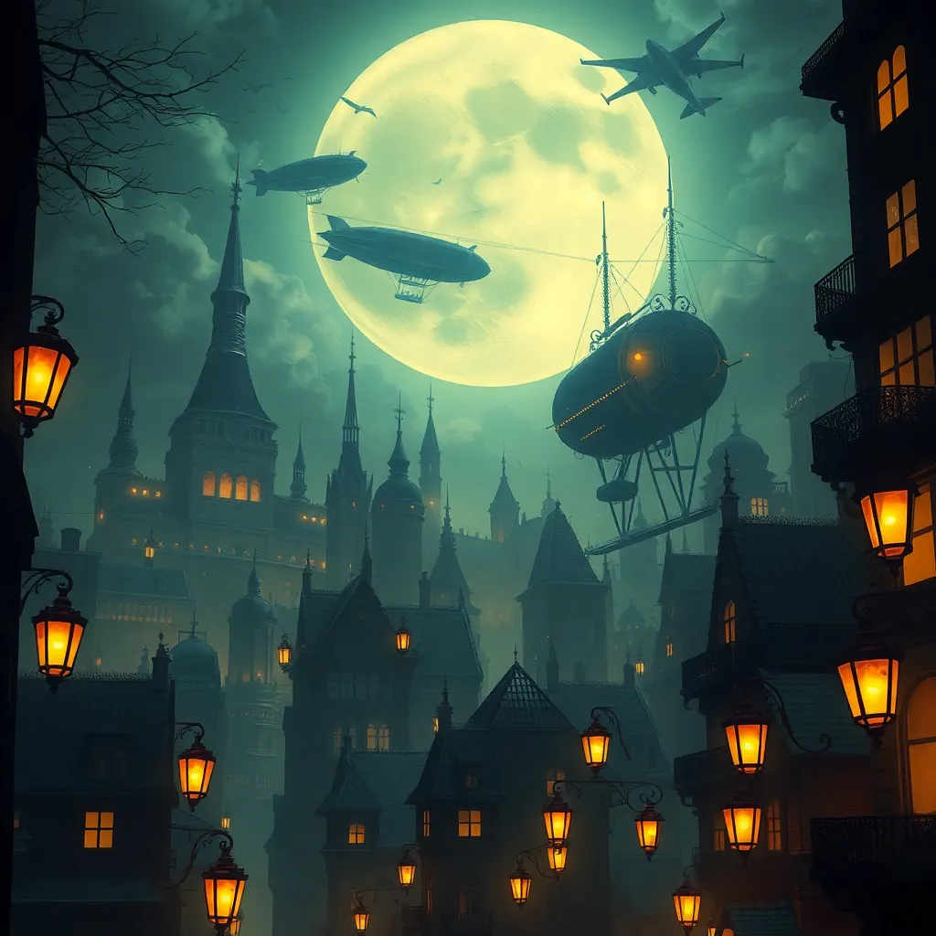

**IMAGE GENERATED WITH DALL-E**

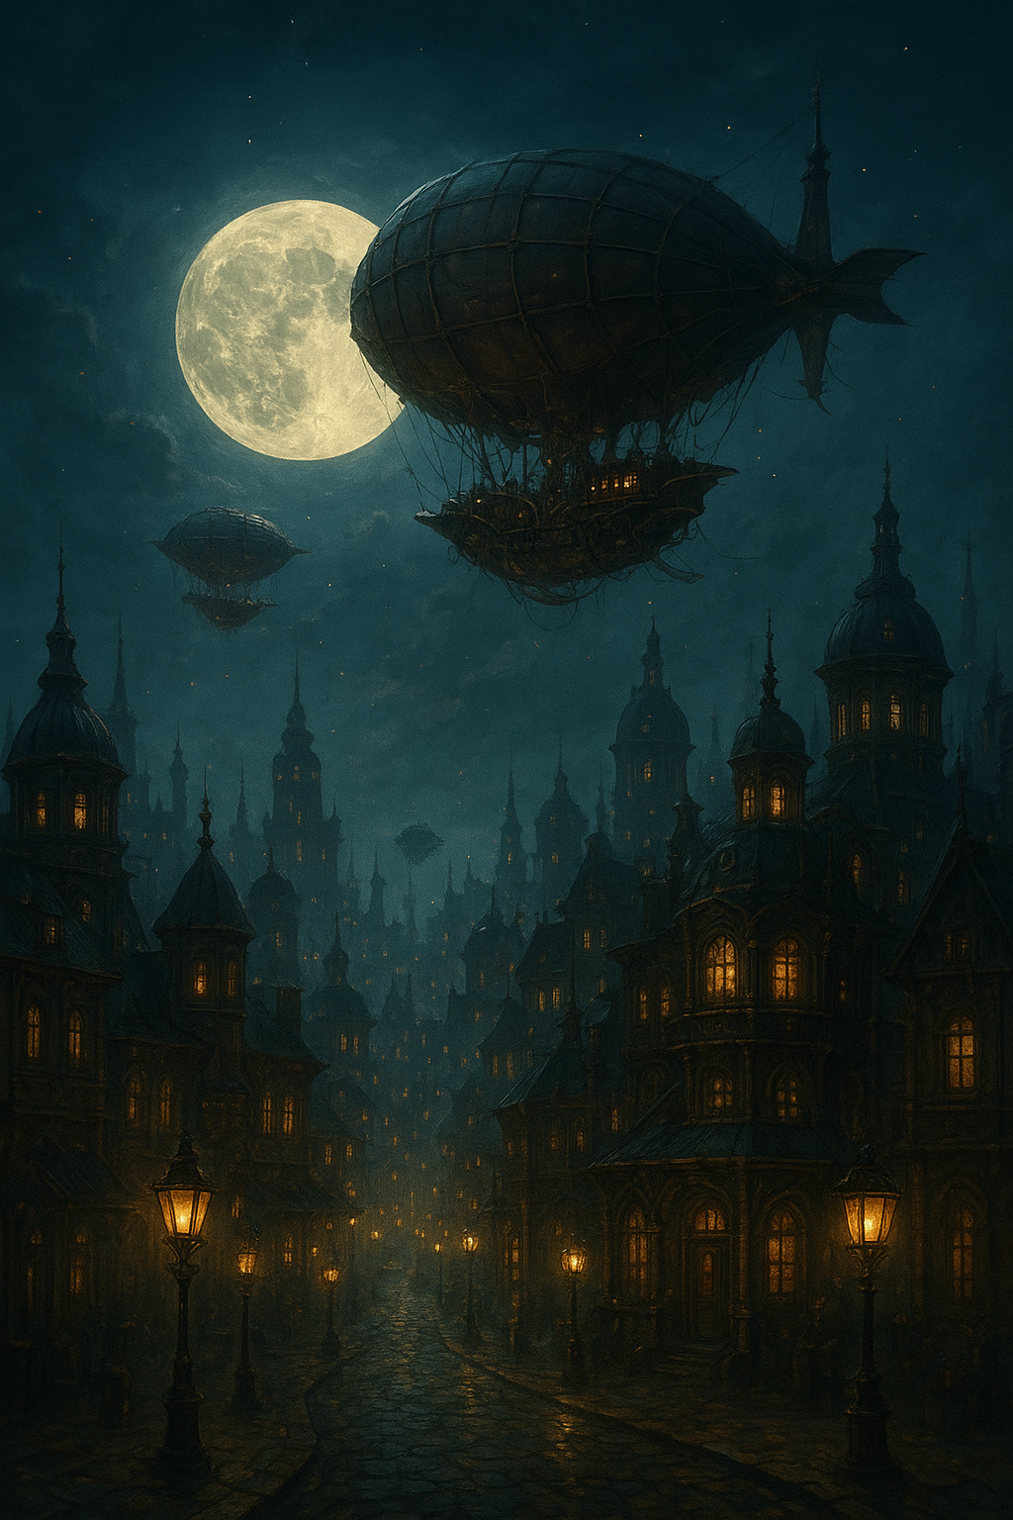

**IMAGE GENERATED WITH MIDJOURNEY**

**Task 2: Visual Design Project**

Chosen topic - Create a poster for a fictional event or product

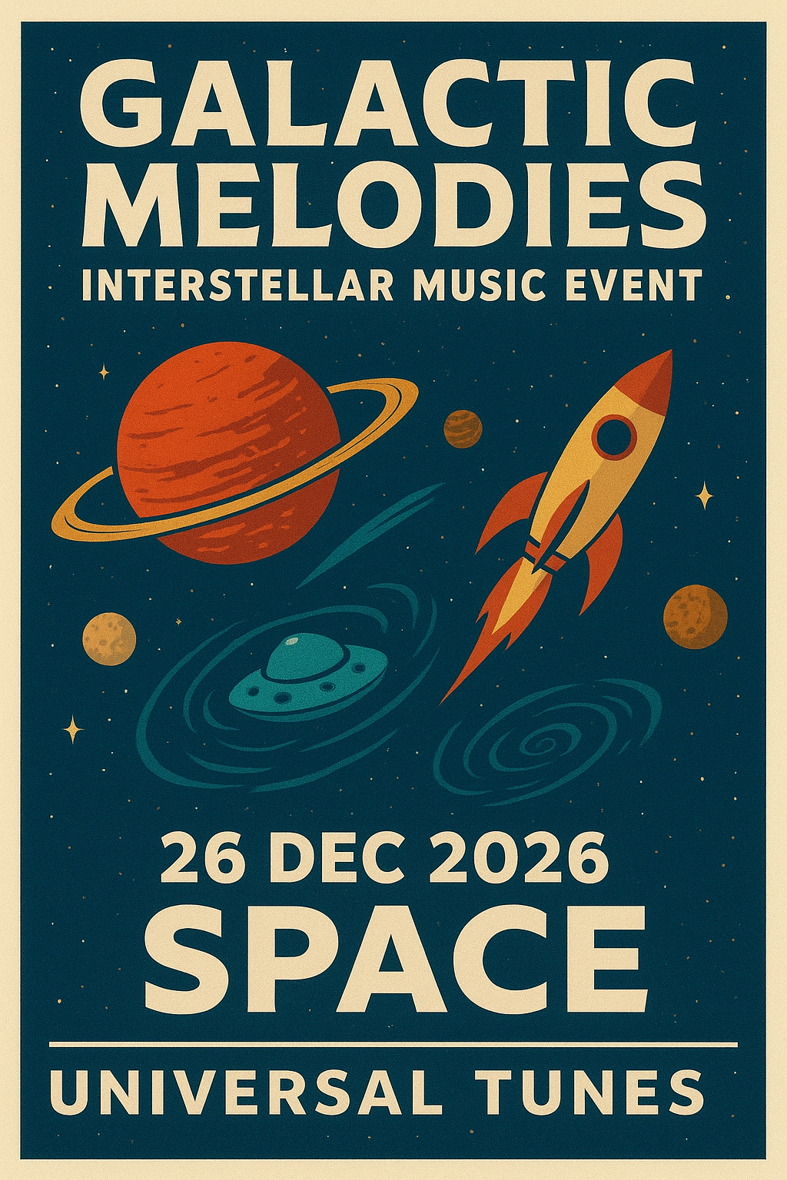

**Practice Activity (If No Direct Access)**

If I do not have access to Midjourney or paid AI tools, I can still complete my visual design tasks by using free or available alternatives. For example:

* I can use **DALL·E in ChatGPT** to generate creative visuals, illustrations, or posters based on prompts I write.
* I can also use **Canva AI tools**, which allow me to create posters, presentations, and graphics with built-in AI design assistance.
* After generating visuals, I can **take screenshots or download the images** to save them for my project.
* These images can then be used to **simulate a story, poster, or presentation**, depending on the assignment’s requirements.